# Search and filter

Use case prioritization

Important

Use case/Services contracts

**Pre-conditions**: A specific Buzz Space has to have been created for a user to be able to search and/or filter. A user does not need to have logged in to perform this operation.

**Post-conditions**: Upon clicking the submit button, the search and/or filter results will be automatically displayed for the user to see.

**Request and results data structures:**

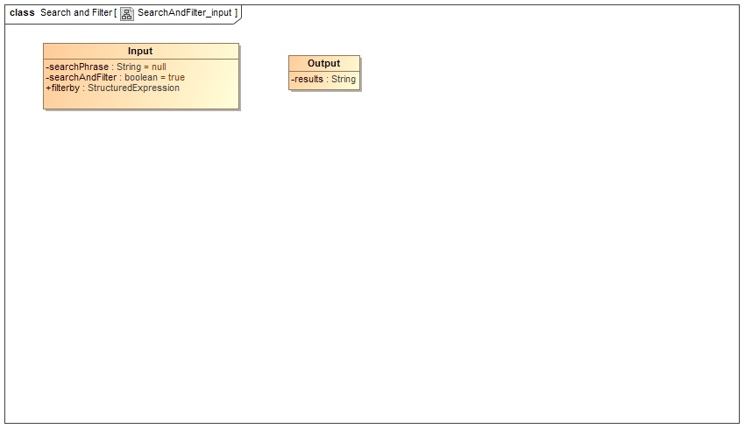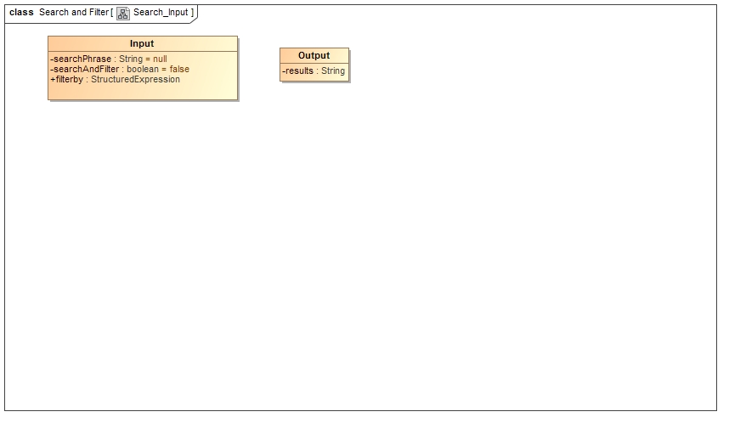

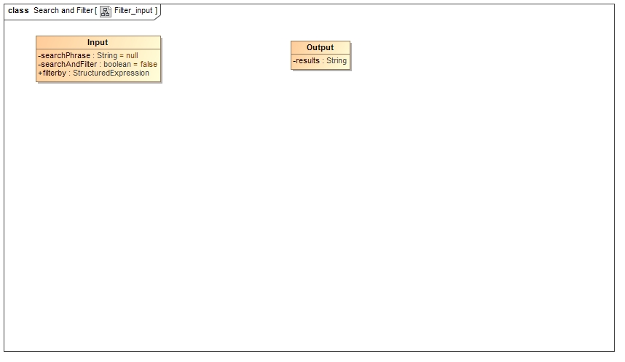

Required Functionality/Use case diagrams

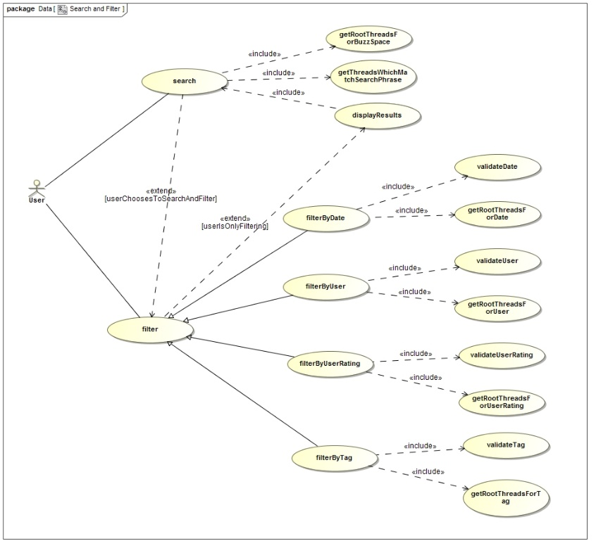

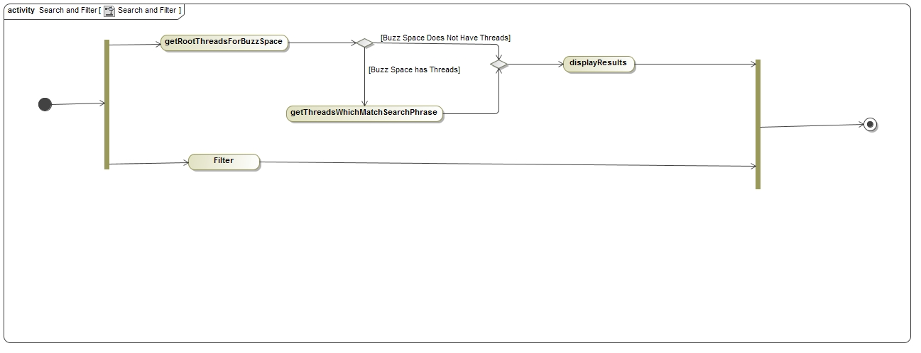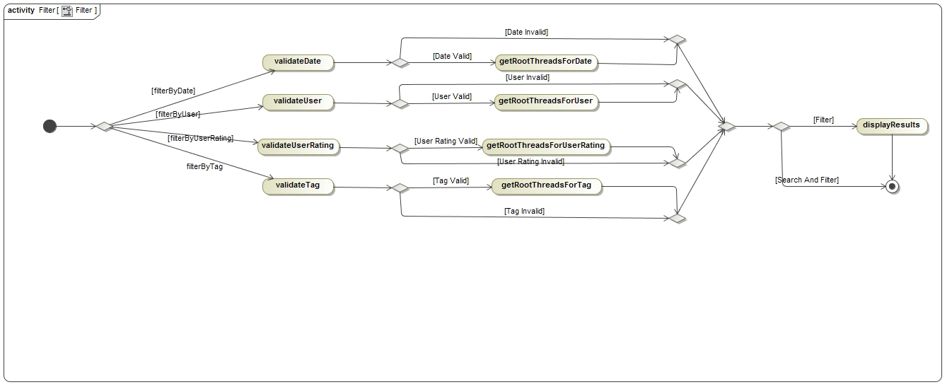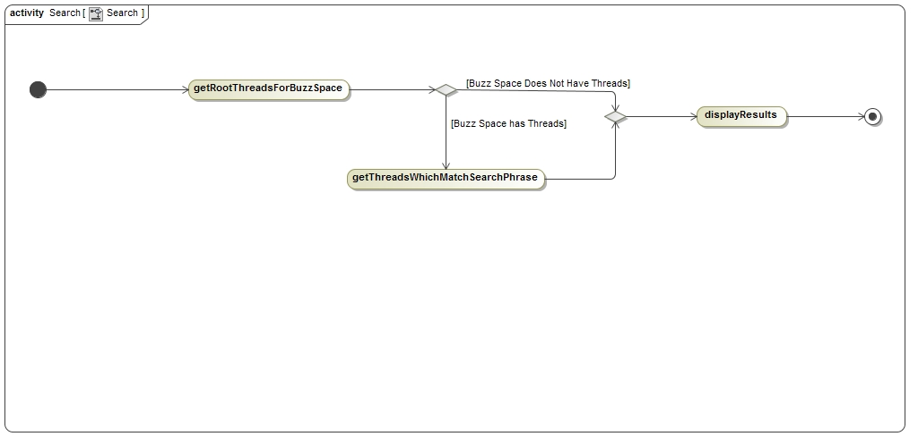Process specifications